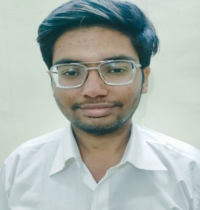

**Samarth Upadhyaya**

Khandari

●

Agra

282007

.

● samarth.upadhyaya@gla.ac.in

●

+91 8899222999

**EDUCATION**

Paste your

profession

al picture

here

**Bachelor of Technology in CSE, *GLA University, Mathura*** 2020-2024

**Intermediate, Milton Public School, Agra** 2019-2020

**High School, Prelude Public School, Agra** 2017-2018

# TRAINING EXPERIENCE_____________________________________________________________________________

**Job Oriented Value Added Course (JOVAC) ,** GLA University(Mathura) June 2022-July 2022

*Web development Training*

**.** Acquired Knowledge about HTML,CSS, JavaScript

**DD TECHNICAL SOLUTIONS** May 2021-Aug 2021

Completed course on the following:

* Complete Course on Java Programming Language
* Data Structure and Algorithm
* Python Programming

## PROJECTS

**Quiz Website (Grouped Project)** June 2022 – July 2022

### Html, CSS , JavaScript

* This project help users to measure their skills and knowledge.
* We use basic front end technologies to develop a very easy and user friendly interface.
* I contribute to HTML and CSS in this project

## SKILLS

**Technical Professional**

**Languages:** Java, Python, JavaScript, HTML ,CSS. Effective Analytical Skills

**Libraries/Frameworks:** BootStrap CSS Leadership experience

**Tools:** GIT, GitHub, MySQL Team work

## EXTRA/CO-CURRICULAR ACTIVITIES

. Participated in google cloud facilitator program 2022 organized virtually by qwiklabs (Google).

.Received Certificate from Udemy for Web Development.

# DECLARATION________________________________________________________________________________________

I hereby declare that all the above mentioned information is true and correct to the best of my knowledge.